

**School of Information Technology**

Course : Diploma in Business Informatics

Subject : ITP282 - Enterprise Application Development & Project

AY / Sem : 2018 S2

# Practical 4b: Security, Login and Roles in ASP.NET

OBJECTIVES:

By the end of this Practical students should able to use:

1. Password Recovery control
2. create user control

## Password Recovery

1. Open the Web Site that you worked on in the **Lab Practical 4a** of this practical.
2. Add a new Web Form and name it *RecoverPassword.aspx*:

It must use the site's Master Page and code behind.

Lay it out as shown in Figure 1:

* 1. The words "Recover Password" is HTML h2.
  2. Drag in a *PasswordRecovery* control from the *Toolbox*. (You do NOT need to create all the buttons and text by yourself.)

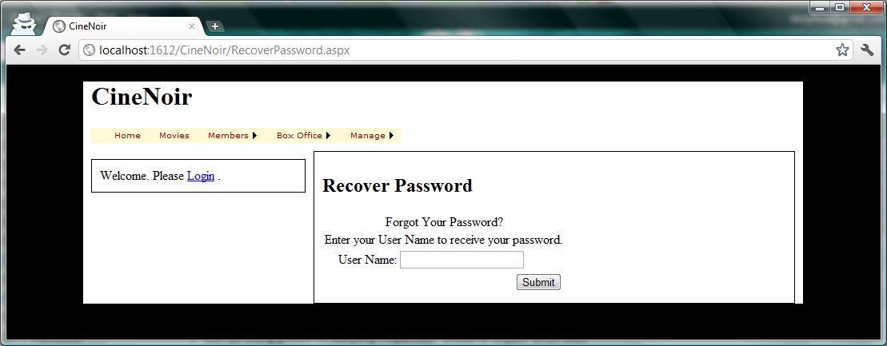

Figure 1

1. This control has 3 views: *UserName*, *Question*, and *Success*. Expand the *Tasks* menu for the *PasswordRecovery* control and use the *Views* drop down list to see them all as shown in Figure 2.

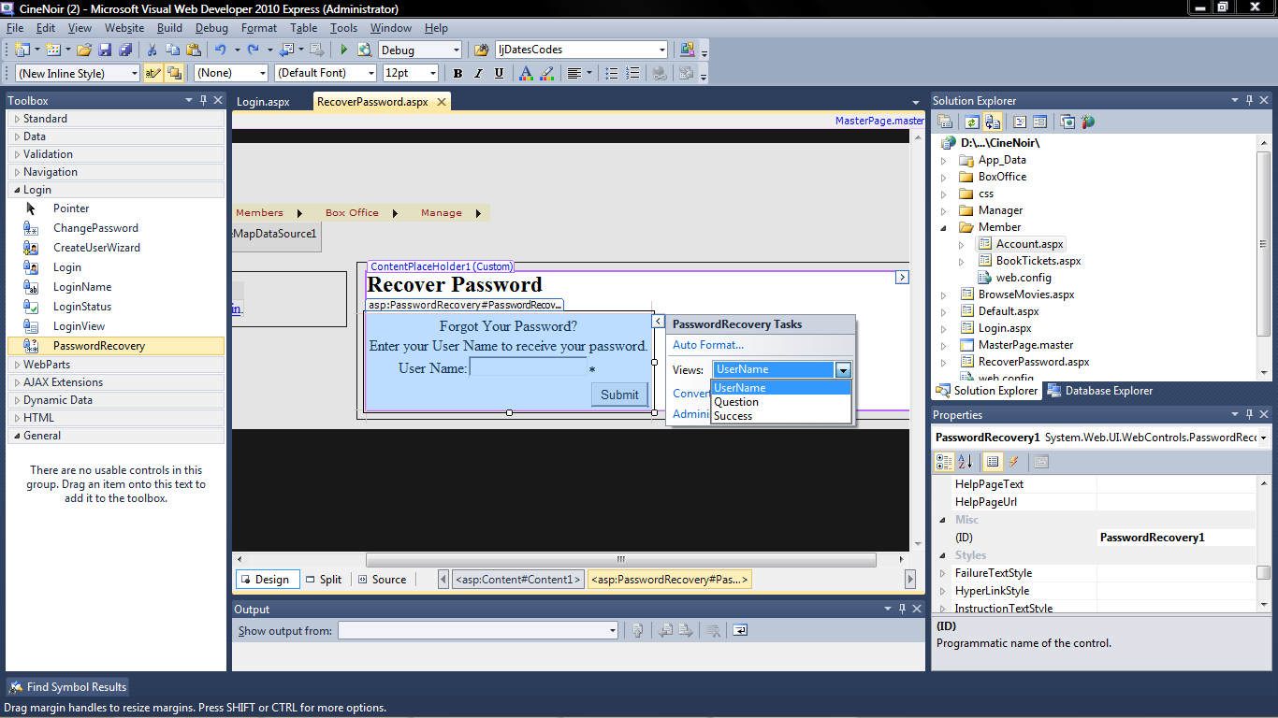

Figure 2

1. Use *View in Browser* to test the page. Try the following:
   1. Type in an incorrect UserName and click Submit.
   2. Try an incorrect answer for the Security question. (Type in a correct UserName first (refer to previous this practical's Part A).)

When you get everything right, you should a see error message like Figure 3, This is because we have not set up the web site's email settings.

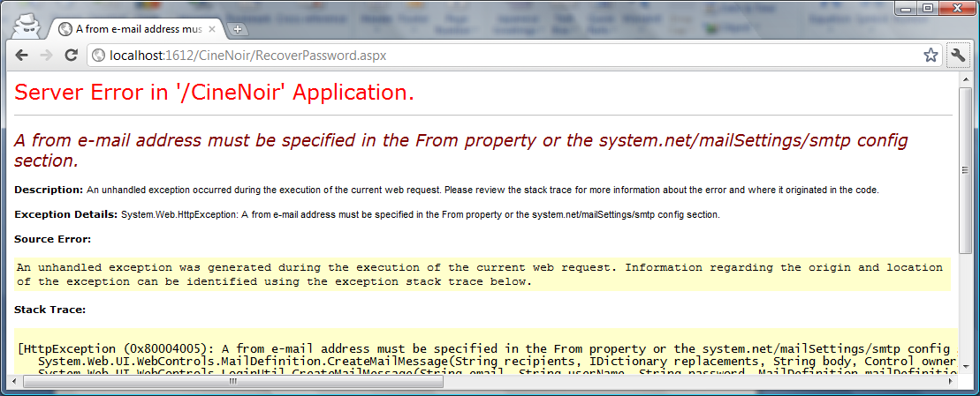

Figure 3

## Setting Up Email for a ASP.NET Web Site

We will NOT be able to send emails from our projects as:

* The poly's SMTP servers are NOT open to arbitrary connections to prevent abuse.
* The poly's firewall blocks connections to external SMTP servers for security reasons.

The following steps will show you **where** you need to make the settings, but you will need to use the SMTP settings for your personal web email account (e.g.: Hotmail, Gmail, Yahoo Mail, etc.) and your own internet connection (e.g.: Broadband dongle, tethering to mobile phone) in order to connect to the server.

1. In VS, go *Website 🡺 ASP.NET configuration*.
2. Click *Application Configuration*.
3. Click *Configure SMTP e-mail settings*.
4. Make the necessary settings in the Configure SMTP Settings page. You can find out the settings from your web email providers support web site.
5. Example: using Hotmail ([IT2606@hotmail.com](mailto:IT2606@hotmail.com)) to send email to SomeJoe’s email account

a. Configuration of SMTP email-setting in ASP.NET

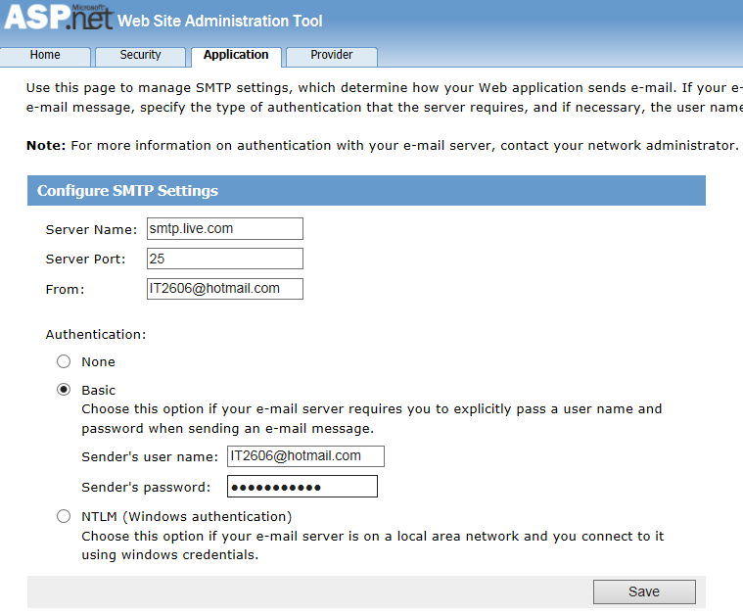

The configuration will be saved in Web.config.

Note: you may need to manually add the **enableSsl=”true”** to the network tag.

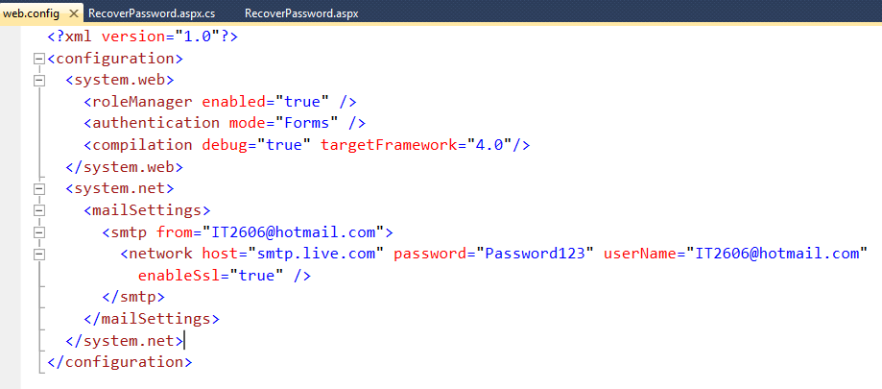

b. view the RecoverPassword.aspx in browser. Key in the username

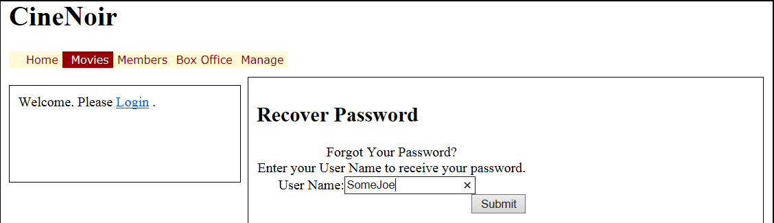

c. key in the answer to the question

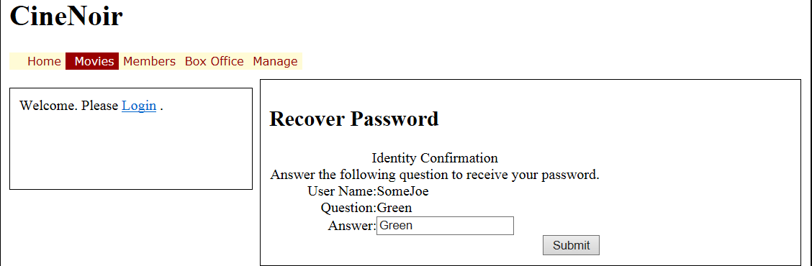

d. confirmation page

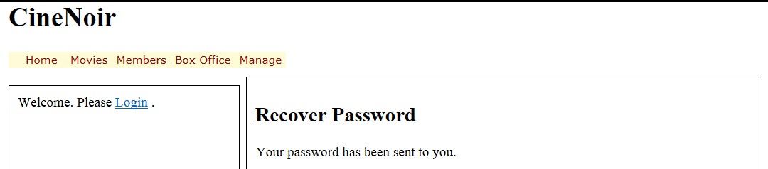

e. go to the SomeJoe’s email to retrieve the newly reset password

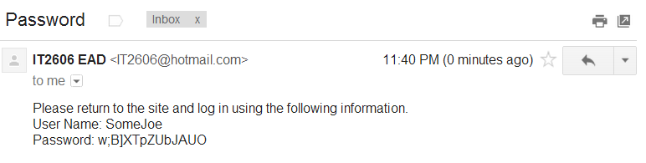

## Registration Page

1. Add a new Web Form and name it *Registration.aspx*:
   1. It must use the site's Master Page and code behind.
2. Lay it out as shown in Figure 4:
   1. The word "Registration" is HTML h2.
   2. Drag in a *CreateUserWizard* control from the *Toolbox*.

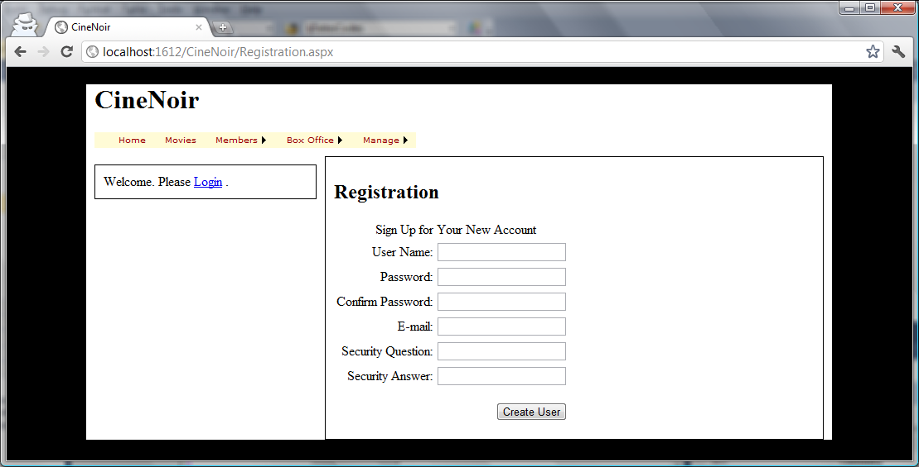

Figure 4

1. Similar to the *PasswordRecovery* control, this control also has several steps. Use its *Tasks* menu to view the different steps. You will also notice that the *Tasks* menu also allows you to *Add/Remove Wizard Steps*. You can use this to create extra steps to capture additional information from the user, but you will need to write your OWN code to insert the extra information into your OWN tables in the database. Explore these options on your own by searching the internet and library books. The resources at the end of Part A of this practical are good places to start.

## Linking the Login Control to the Above

You can link to these pages the usual way, by providing links from various parts of your web site, like the menu bar, etc. There are also built-in settings that let you link to these pages from the login control

1. Open Login.aspx.
2. Select the login control on your page and make the following property settings:
   1. PasswordRecoveryText: Forgot Password?
   2. PasswordRecoveryUrl: (Click the … button and browse and select *RecoverPassword.aspx.*)
3. Find the appropriate settings for Create User and make the necessary settings.
4. Test the page.

## Using Code to Get the Currently Logged In User

Now that we have set up ASP.NET Web Site security, ASP.NET will take care of the logging in, logging out, user accounts etc for us. Often we need to link the user to additional information in our web site and database, such as shopping carts, invoices, orders, profiles, etc. To do that we need to be able to get hold of the user that is currently logged in and other user manipulation functions. ASP.NET provides several classes to facilitate that. As far as possible, avoid modifying the ASP.NET tables directly with SQL. It is quite safe to read directly from them in necessary, or even join your own tables to them in queries, but you should never update, insert and delete from the ASP.NET tables directly with SQL. Below we show some sample code to get the currently logged in user, if any.

1. Open *Account.aspx* which is in the *Members* folder.
2. In Source View, make the following amendments as shown in Figure 5. (You may also use the Design view to make the changes.)

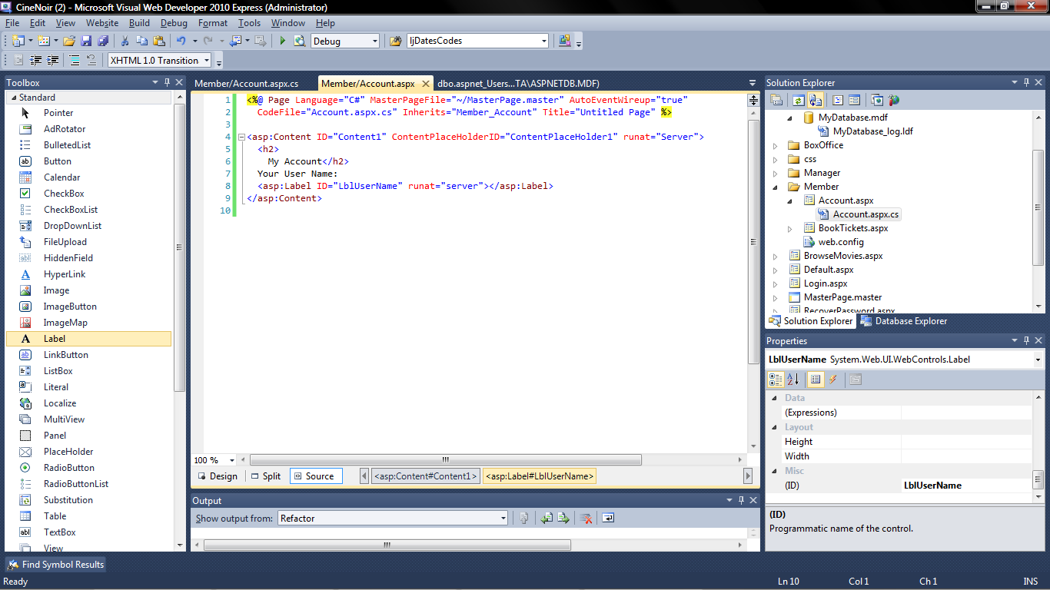

Figure 5

1. In *Account.aspx.cs*, add the code shown in Figure 6.

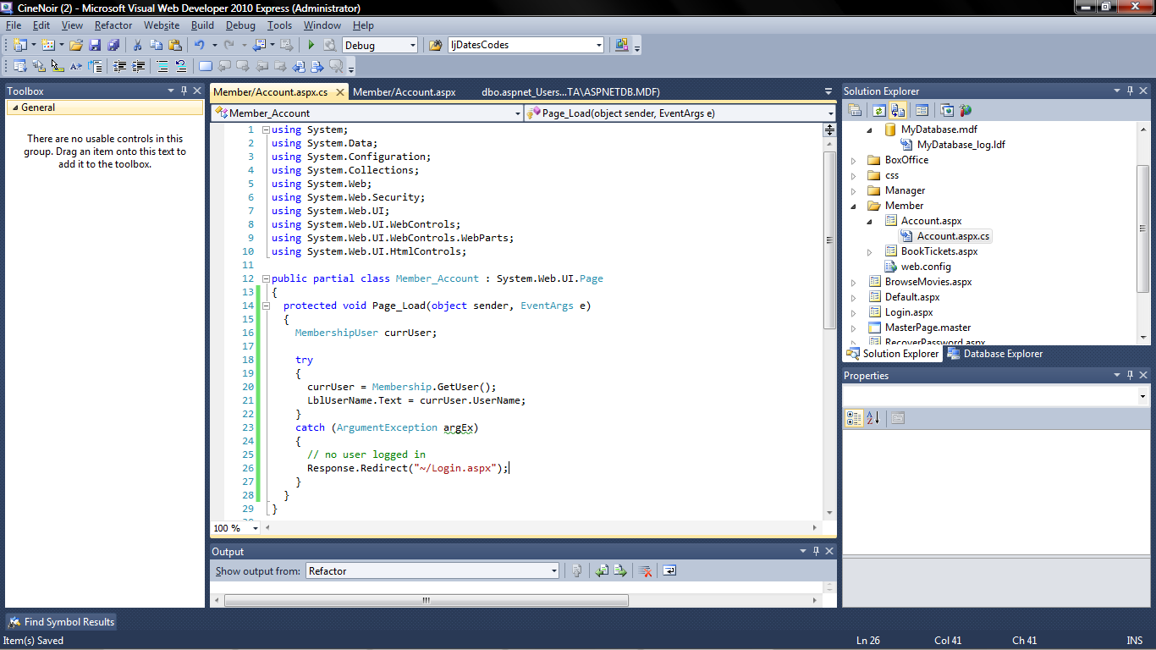

Figure 6

1. Now test the page. If you get the following errors, you need to perform the following steps to fix them. Otherwise, skip to step 7 below.
2. If you get "The type or namespace name 'MembershipUser' could not be found (are you missing a using directive or an assembly reference?)":
   1. In VS, select *Website 🡺 Add Reference…*.
   2. In the *Add Reference* dialog, select the .NET tab.
   3. Scroll down the list and select *System.Web.ApplicationServices*.
   4. Click the OK button.
3. If you get "The type or namespace name 'Linq' does not exist in the namespace 'System' (are you missing an assembly reference?)":
   1. Open *Accounts.aspx.cs* and delete the line "using System.Linq;".
4. Login as *SomeJoe*.
5. Now that you can access the currently logged in user, if necessary, you can get information from it to insert into your tables. Explore more using the resources listed in Part A, MSDN documentation on the *Membership* and *MembershipUser* classes and searching the internet and library.

**========== End ==========**